**TASK-10 🡪 JAVA OOPS:**

1. ***Create class name🡪person , attributes🡪 name and age, create🡪 constructor, create 🡪getter method for attributes.***

**Code:**

**package** Task10;

**import** java.util.*;

**public** **class** person { // class name

**private** String name; // attributes name and age.

**private** **int** age;

**public** person(String name,**int** age) { //constructor

**this**.name=name;

**this**.age=age;

}

**public** String getName() { //getter methods for attributes

**return** name;

}

**public** **int** getAge() {

**return** age;

}

**public** **static** **void** main(String[] args) { //main method

person PersonObject1=**new** person("paramu",24); // create a object and passing parameter

person PersonObject2=**new** person("sankari",26);

String name1=PersonObject1.getName();

**int** age1=PersonObject1.getAge();

String name2=PersonObject2.getName();

**int** age2=PersonObject2.getAge();

System.***out***.println("student-1");

System.***out***.println("name:"+name1);

System.***out***.println("age:"+age1);

System.***out***.println("___________________________");

System.***out***.println("student-2");

System.***out***.println("name:"+name2);

System.***out***.println("age:"+age2);

System.***out***.println("___________________________");

}

}

Output:

student-1

name:paramu

age:24

___________________________

student-2

name:sankari

age:26

__________________________

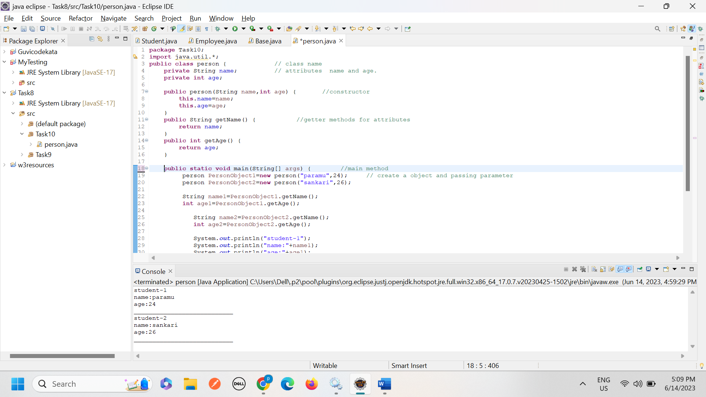

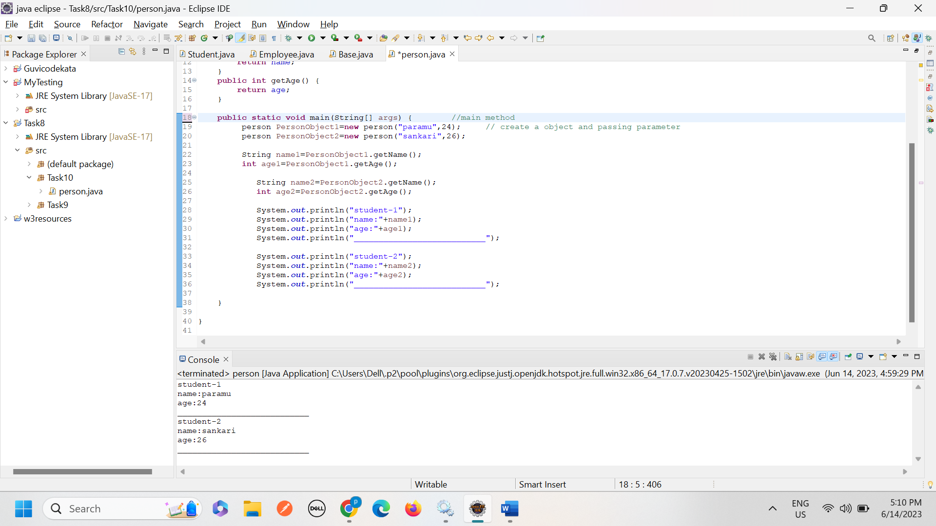

_______---------------------------------------------------------------------------------------------------------------------------------------------------------------

1. ***From the Image🡪***

***create 🡪class name🡪Employee.***

***Attributes🡪ID, Name, salary.***

***Create 🡪method name🡪raiseSalary(percent).***

***Update the salary by a specified percentage.***

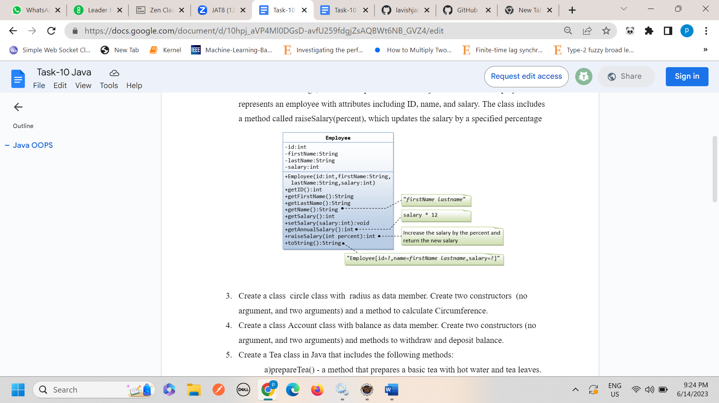

**Code:**

**package** Task10;

**public** **class** Employee { //class name Employee

//instance variable

**private** **int** ID;

**private** String Firstname;

**private** String LastName;

**private** String name;

**private** **int** salary;

//create constructor

**public** Employee(**int** ID,String Firstname, String LastName,String name ,**int** salary) {

**this**.ID=ID;

**this**.Firstname=Firstname;

**this**.LastName=LastName;

**this**.name=name;

**this**.salary=salary;

}

**public** **int** getID() { //getter method-->getID

**return** ID;

}

**public** String getFirstname() { //getter method-->getFirstName

**return** Firstname;

}

**public** String getLastName() { //getter method-->getLastName

**return** LastName;

}

**public** String getName() { //getter method-->getLastName

**return** name;

}

**public** **int** getSalary() { //getter method-->getSalary

**return** salary;

}

**public** **void** setSalary(**int** salary) { //setter method-->setSalary

**this**.salary = salary;

}

**public** **int** raiseSalary(**int** percent) { //raiseSalary -->percent =10

**double** IncreasingSalary=salary*(percent/100.0);

System.***out***.println("IncreasingSalary ::"+IncreasingSalary);

salary= salary+(**int**)IncreasingSalary;

**return** salary;

}

**public** **int** getAnnualSalary() {

**return** salary*12;

}

**public** String toString() { //return employee details

**return** "Employee[ID=" +ID+ ", name=" +Firstname+""+LastName+ ", Salary="+salary+"]";

}

**public** **static** **void** main(String[] args) {

//create a object for class employee and passing parameter.

Employee EmployeObject=**new** Employee(234,"paramu","p","paramup", 15000);

System.***out***.println("Employee ID ::"+EmployeObject.getID());

System.***out***.println("Employee FirstName::"+EmployeObject.getFirstname());

System.***out***.println("Employee LastName ::"+EmployeObject.getLastName());

System.***out***.println("Employee name ::"+EmployeObject.getName());

System.***out***.println();

System.***out***.println("Initial salary ::"+EmployeObject.salary);

System.***out***.println("Raise Salary ::"+EmployeObject.raiseSalary(10)); //raising salary 10%

System.***out***.println("Annaul salary ::"+EmployeObject.getAnnualSalary());

System.***out***.println("employee details ::"+EmployeObject.toString());

}

}

Output:

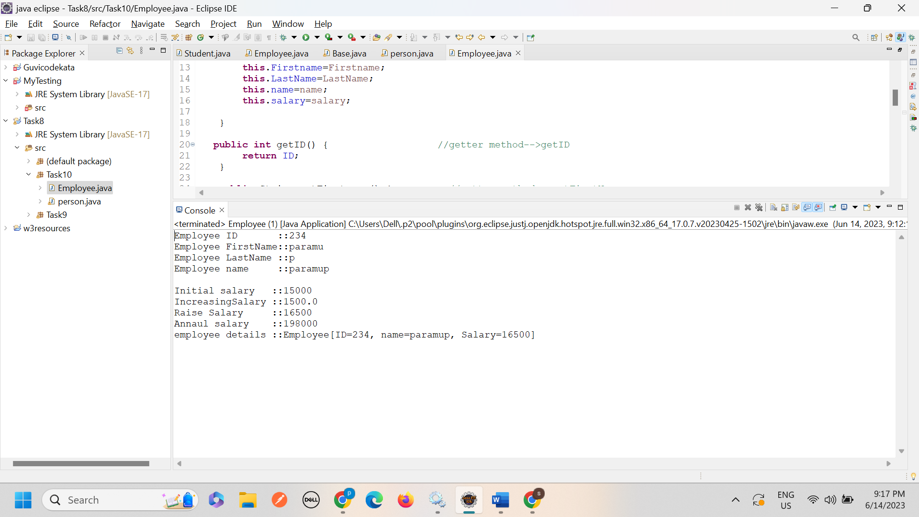

**Code screenshot:**

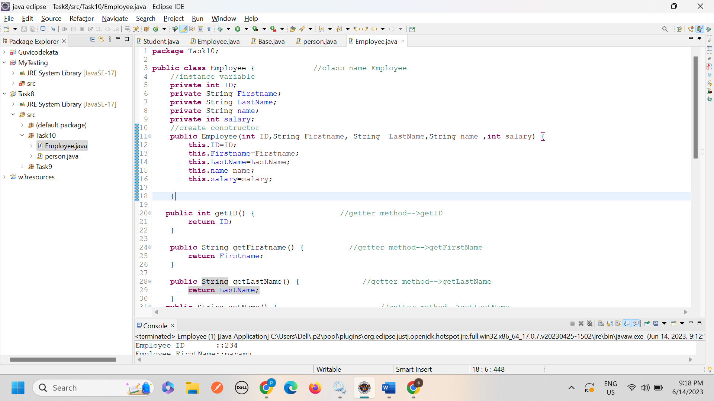

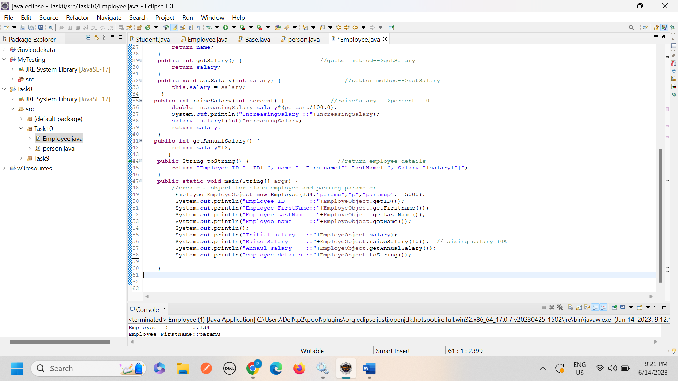

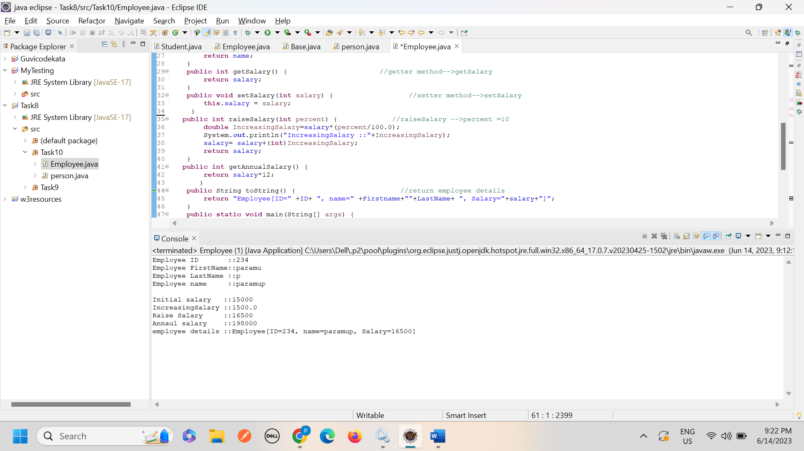

1. ***Create a class circle class with radius as data member. Create two constructors (no and two arguments) and a method to calculate Circumference.***

***Create🡪class name🡪circle.***

***Data member or variable🡪 radius.***

***Create🡪Two constructor(no and two arguments).***

***Create🡪method name🡪circumference🡪calculate the circumference of circle.***

**Code:**

**package** Task10;

**import** java.util.*;

**public** **class** circle { // create a class name-->circle.

**private** **double** radius; // create a variable or data member.

**public** circle() { // create constructor with no arguments

radius=0.0;

}

**public** circle(**double** radius) { // create constructor with arguments

**this**.radius=radius;

}

**public** **double** circumference() { // create method for calculate the circumference=2 * pi * r;

**return** 2* Math.***PI*** *radius; // calculate the circumference of circle

}

**public** **static** **void** main(String[] args) {

circle cobject=**new** circle(6.0); //create object name and passing parameter.

System.***out***.println(cobject.circumference());

}

}

Output:

37.69911184307752

**Output and code screenshot:**

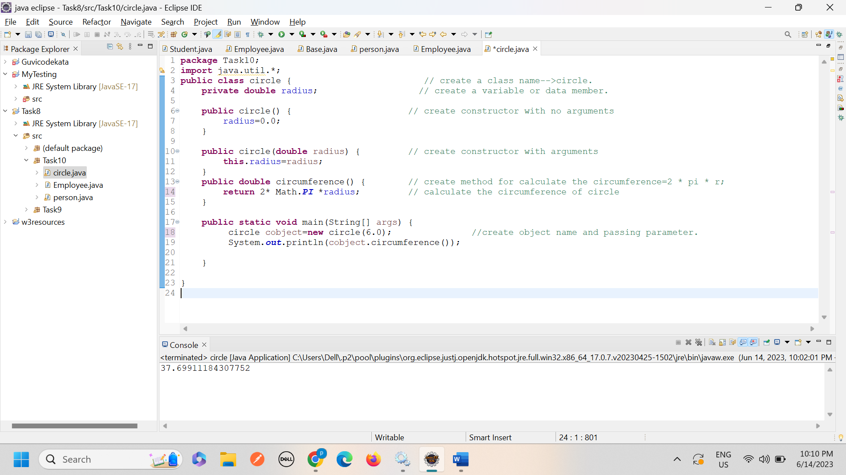

1. ***Create a class Account class with balance as data member. Create two constructors (no argument, and two arguments) and methods to withdraw and deposit balance.***

***Create🡪class🡪Account.***

***Data member🡪balance.***

***Create🡪two constructor🡪(no arguments, two arguments).***

***Create🡪methods🡪withdraw, desposit balance.***

**Code:**

**package** Task10;

**public** **class** Account { //create a class name-->Account

//instance variable

**private** **double** balance; // create data member or variable.

**private** **double** amount;

**public** Account() { // create constructor without arguments.

**double** balance;

}

**public** Account(**double** balance,**double** amount) { //create constructor with arguments.

**this**.balance=balance;

**this**.amount=amount;

}

**public** **double** withdraw() { //method name-->withdraw

**double** withdraw_amount=balance-amount;

**return** withdraw_amount;

}

**public** **double** deposit() { // method name-->deposit

**return** amount+balance;

}

**public** **static** **void** main(String[] args) {

Account Aobject=**new** Account(1000,500); // create an object

System.***out***.println("withdraw_amount ::"+ Aobject.withdraw());

System.***out***.println("deposit ::"+ Aobject.deposit());

}

}

**Output and code screenshot:**

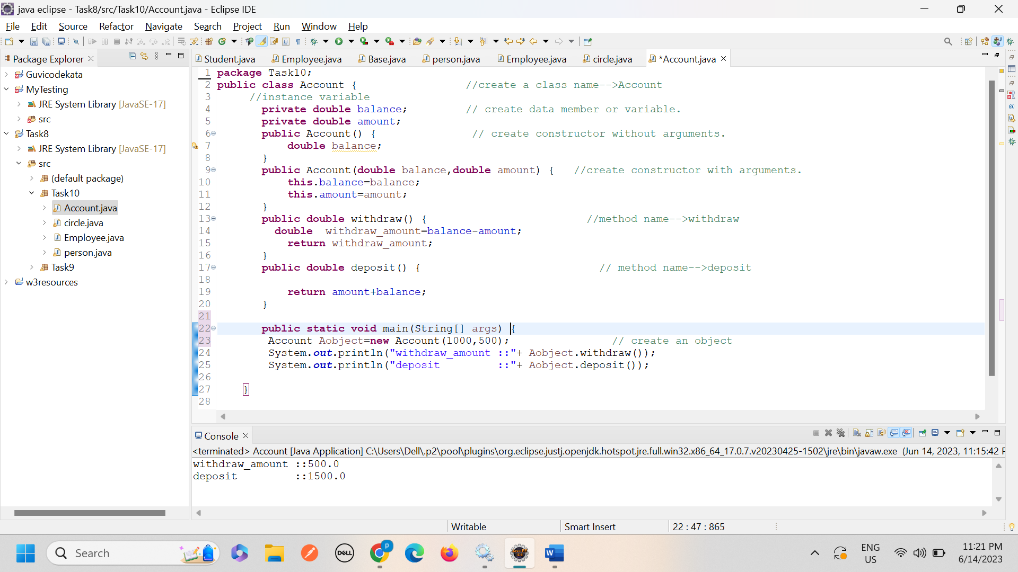

***Create 🡪class🡪Tea***

***Create 🡪method🡪prepare tea()🡪 a method that prepares a basic tea with hot water and leaves.***

***Create🡪methods🡪addmilk()🡪a method that adds milk to the basic tea.***

***Create 🡪methods🡪addsugar()🡪 amethod that add sugar to the basic tea.***

**Code:**

**package** Task10;

**public** **class** Tea { // create class name-->tea

**public** **void** PrepareTea() // create method name-->PrepareTea

{

System.***out***.println("prepare a basic tea with hot water and leaves");

}

**public** **void** addmilk() { // create method name-->addmilk

System.***out***.println("adding milk to the tea");

}

**public** **void** addsugar() { // create method name-->addsugar

System.***out***.println("adding sugar to the tea");

}

**public** **static** **void** main(String[] args) {

Tea Tobject=**new** Tea(); //create an object for tea class and accessing a tea class methods.

Tobject.PrepareTea();

Tobject.addmilk();

Tobject.addsugar();

}

}

***Output and code screenshot:***

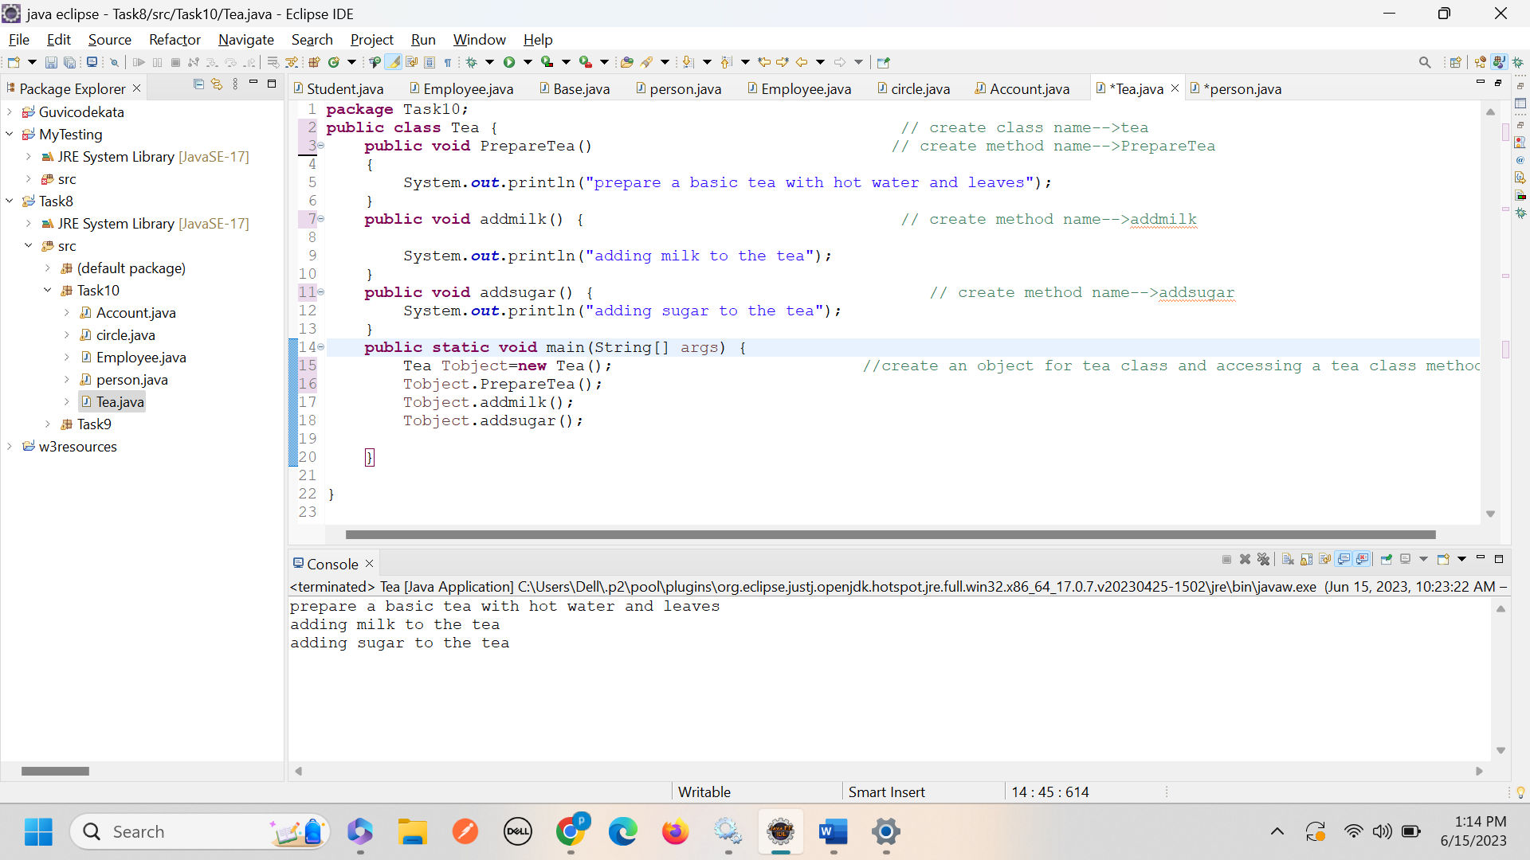

1. ***Create 🡪three subclasses or child class for Tea Class.***

***Subclasses should override🡪PrepareTea method🡪And prepare a specific type of (black tea, green tea, herbal tea) with ingredients and brewing times.***

***Code:***

***Parent class:***

**package** Task10;

**public** **class** Tea1 { //Base class or parent class or super class

**protected** String TeasName; //instance variable

**public** Tea1(String name) { //constructor

**this**.TeasName=name;

}

**public** **void** getDetails() { //create getter method

System.***out***.println("Basic tea::"+TeasName);

PrepareTea() ;

}

**void** PrepareTea() { // create method name-->PrepareTea

System.***out***.println("prepare a basic tea with hot water and leaves");

}

}

___________________________

***Child class-1🡪Black tea:***

**package** Task10;

**public** **class** BlackTea **extends** Tea1{

**public** BlackTea(String name) { //constructor for BlackTea

**super**(name+"tea");

}

//preparing black tea -->writing about,what are ingredients and brewing times

@Override

**public** **void** PrepareTea() {

System.***out***.println("Adding two cup of water in saucepan");

System.***out***.println("Boiling the water 5 mins");

System.***out***.println("Adding a tea podwer in boling water");

System.***out***.println("The tea powder taken times to boil 10 mins ");

System.***out***.println("Adding sugar in tea");

System.***out***.println("Finaly filtering and serve it");

}

**public** **void** getDetails() { //get method

PrepareTea();

}

}

_____________________________________________________________________________________

Child class🡪2🡪Green tea

**package** Task10;

**public** **class** GreenTea **extends** Tea1{

**public** GreenTea(String name) { //constructor for GreenTea

**super**(name+"GreenTea");

}

//preparing Green tea -->writing about,what are ingredients and brewing times

@Override

**public** **void** PrepareTea() {

System.***out***.println("Adding two cup of water in saucepan");

System.***out***.println("Boiling the water 5 mins");

System.***out***.println("Adding lemon juice in boling water");

System.***out***.println("Adding spearment leaf in the hot water");

System.***out***.println("Adding Holi basil leak in the hot water");

System.***out***.println("The tea taken times to boil 15 mins ");

System.***out***.println("Adding sugar in tea");

System.***out***.println("Finaly filtering and serve it");

}

**public** **void** getDetails() { //getter method

PrepareTea();

}

}

Child class🡪3🡪Herbal tea

Code:

**package** Task10;

**public** **class** HerbalTea **extends** Tea1{

**public** HerbalTea(String name) { //constructor for HerbalTea

**super**(name+"HerbalTea");

}

//preparing Herbal tea -->writing about,what are ingredients and brewing times

@Override

**public** **void** PrepareTea() {

System.***out***.println("Adding two cup of water in saucepan");

System.***out***.println("Boiling the water 5 mins");

System.***out***.println("Adding lemon juice in boling water");

System.***out***.println("Adding spearment leaf in the hot water");

System.***out***.println("Adding Holi basil leak in the hot water");

System.***out***.println("Adding 2 spoon tea powder");

System.***out***.println("The tea taken times to boil 15 mins ");

System.***out***.println("Adding sugar in tea");

System.***out***.println("Finaly filtering and serve it");

}

**public** **void** getDetails() { //getter method

PrepareTea();

}

}

Main class:

Code:

**package** Task10;

**public** **class** CheckTea {

**public** **static** **void** main(String[] args) {

BlackTea blacktea=**new** BlackTea("BlackTea"); //object creation and passing parameter

GreenTea greenTea=**new** GreenTea("GreenTea");

HerbalTea herbalTea=**new** HerbalTea("HerbalTea");

blacktea.getDetails();

System.***out***.println("_____________________________________");

greenTea.getDetails();

System.***out***.println("_____________________________________");

herbalTea.getDetails();

System.***out***.println("_____________________________________");

}

}

_______________________________________________________________________________

__________________________________________________________________________________________________________________

***Output and code screenshot:***

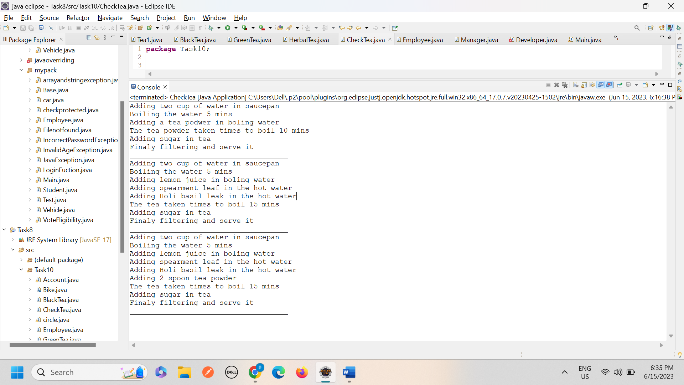

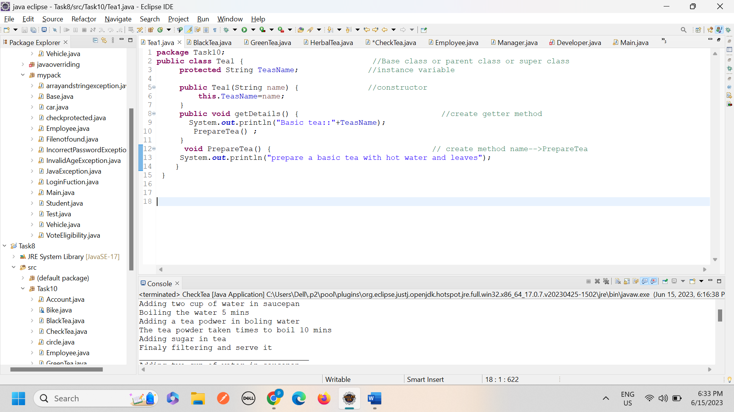

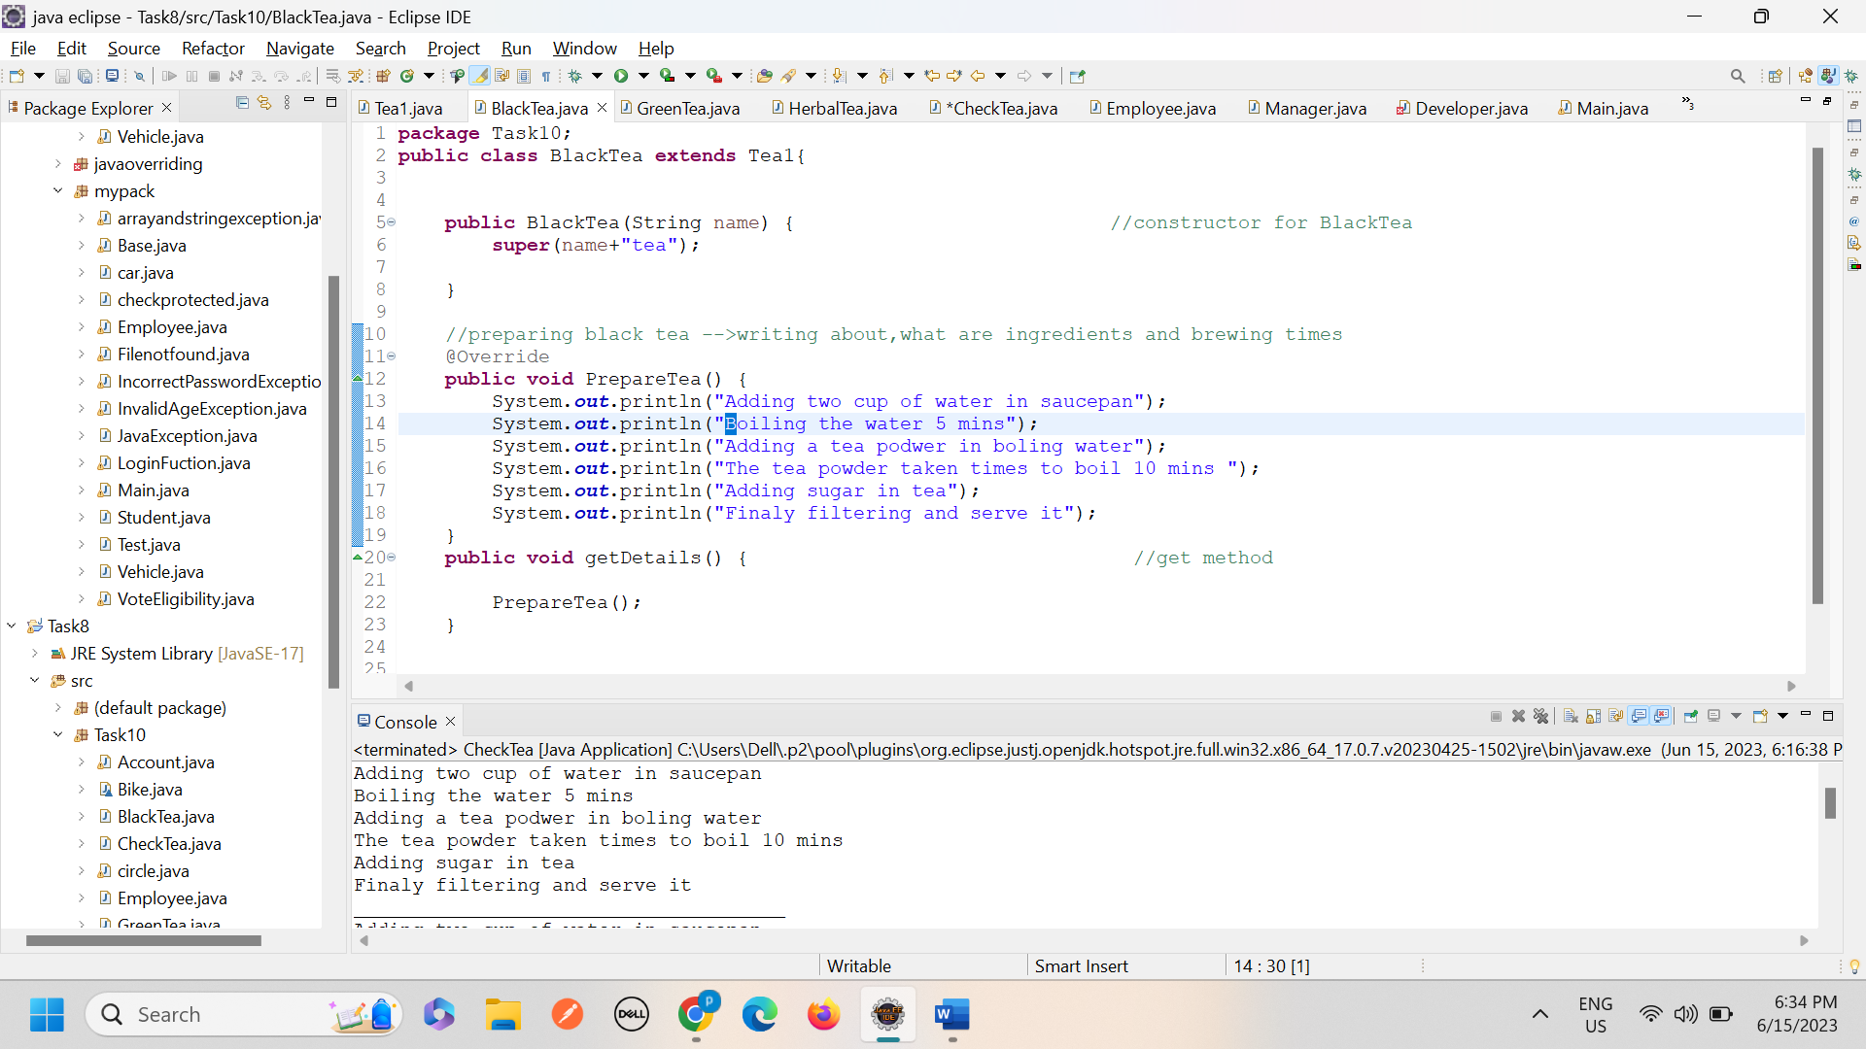

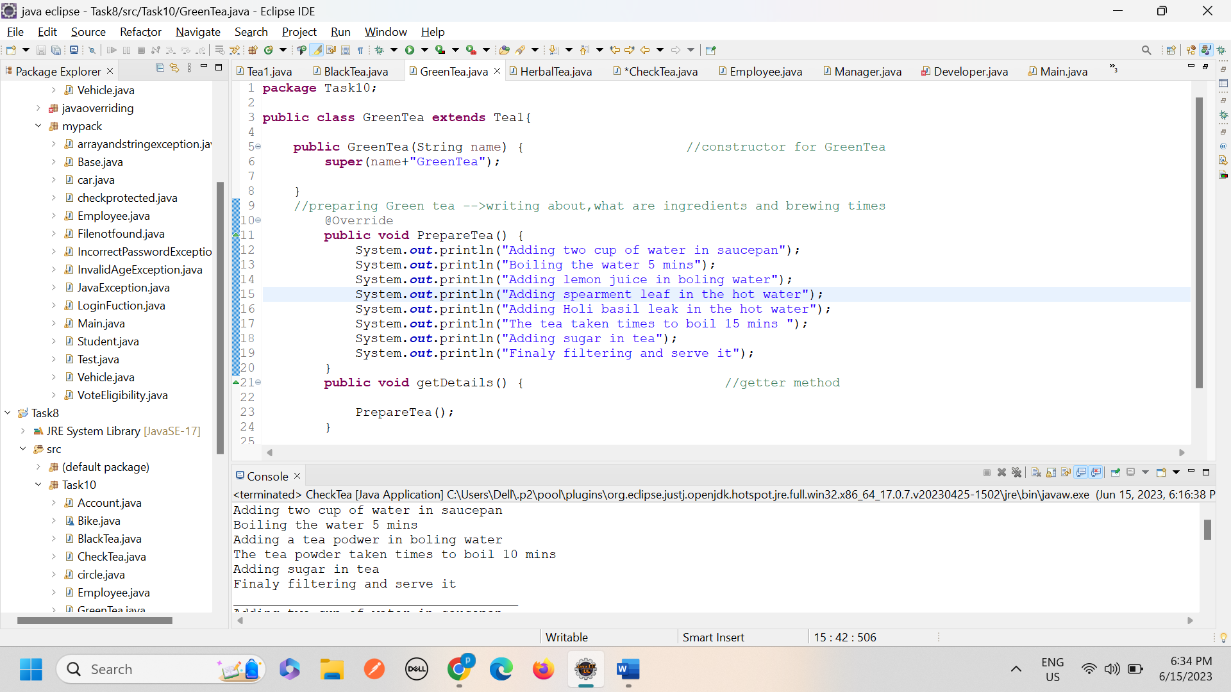

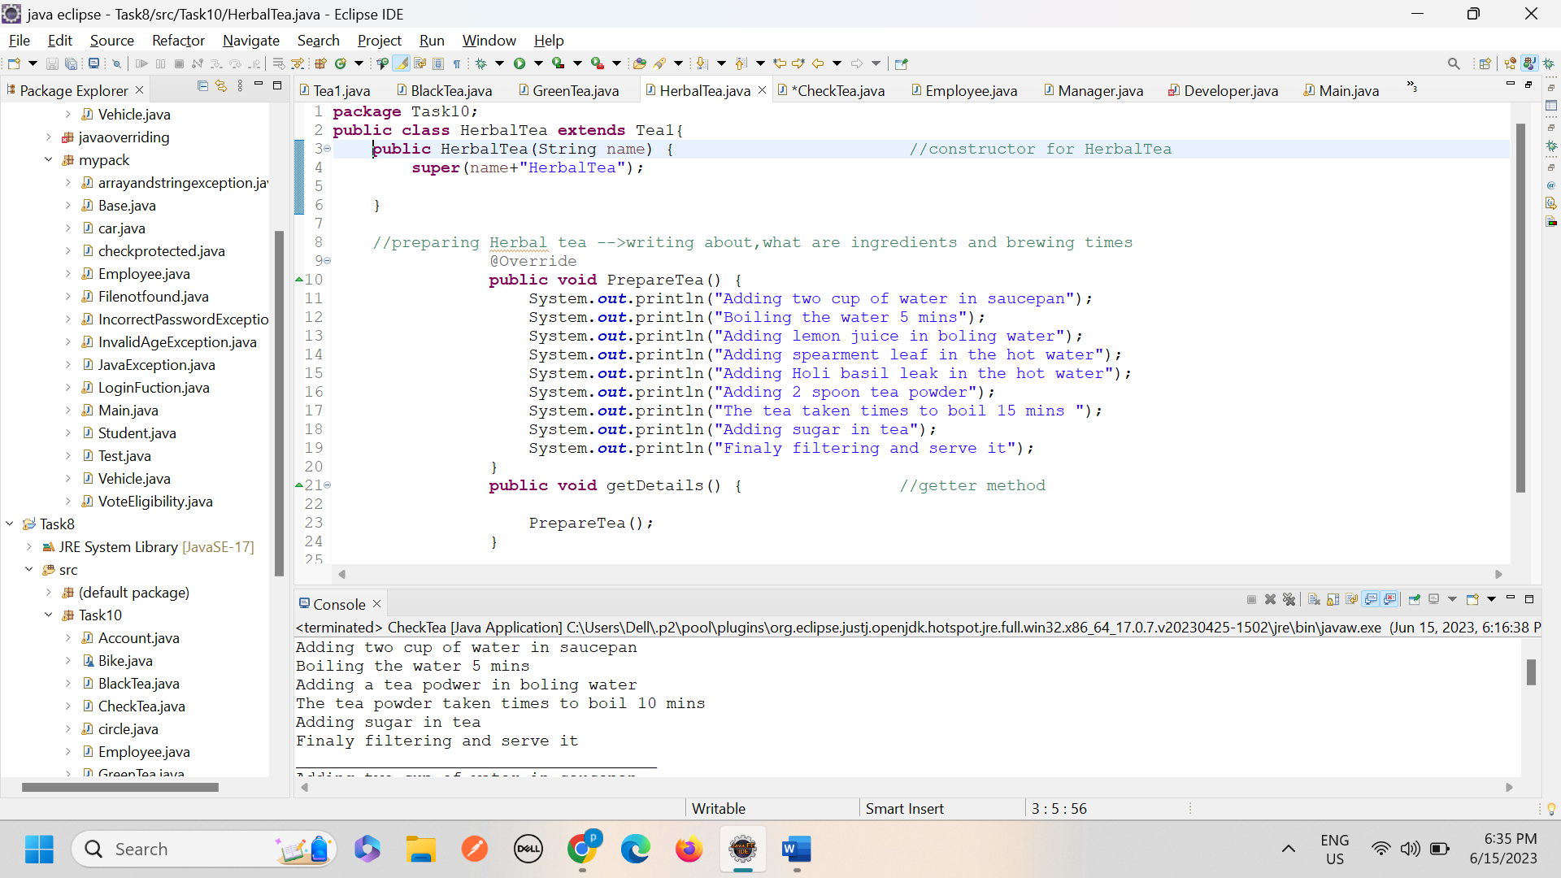

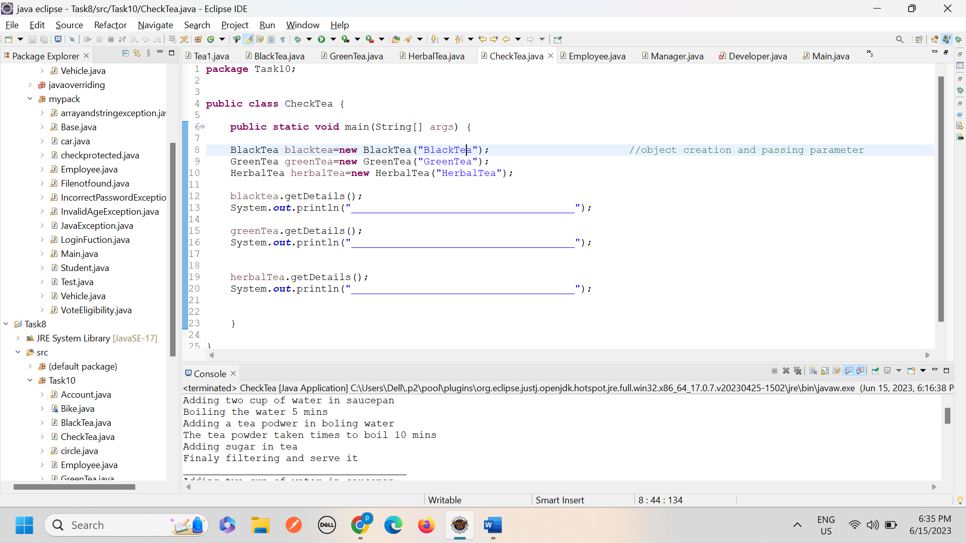

1. ***Implement polymorphism in your program by creating an array of tea objects that includes instances of the tea class and its subclasses.***

***Code:***

**public** **class** Tea { //Base class or parent class or super class

**protected** String TeasName; //instance variable

**public** Tea(String name) { //constructor

**this**.TeasName=name;

}

**public** **void** getDetails() { //create getter method

System.***out***.println("Basic tea::"+TeasName);

PrepareTea() ;

}

**void** PrepareTea() { // create method name-->PrepareTea

System.***out***.println("prepare a basic tea with hot water and leaves");

}

}

***Child class-1 or subclass***

**public** **class** BlackTea **extends** Tea{ //child class or subclass

**public** BlackTea(String name) { //constructor for BlackTea

**super**(name+"tea");

}

//preparing black tea -->writing about,what are ingredients and brewing times

@Override

**public** **void** PrepareTea() {

System.***out***.println("Adding two cup of water in saucepan");

System.***out***.println("Boiling the water 5 mins");

System.***out***.println("Adding a tea podwer in boling water");

System.***out***.println("The tea powder taken times to boil 10 mins ");

System.***out***.println("Adding sugar in tea");

System.***out***.println("Finaly filtering and serve it");

}

**public** **void** getDetails() { //get method

PrepareTea();

}

}

***___________________________________________***

***Child class-2***

**public** **class** GreenTea **extends** Tea{

**public** GreenTea(String name) { //constructor for GreenTea

**super**(name+"GreenTea");

}

//preparing Green tea -->writing about,what are ingredients and brewing times

@Override

**public** **void** PrepareTea() {

System.***out***.println("Adding two cup of water in saucepan");

System.***out***.println("Boiling the water 5 mins");

System.***out***.println("Adding lemon juice in boling water");

System.***out***.println("Adding spearment leaf in the hot water");

System.***out***.println("Adding Holi basil leak in the hot water");

System.***out***.println("The tea taken times to boil 15 mins ");

System.***out***.println("Adding sugar in tea");

System.***out***.println("Finaly filtering and serve it");

}

**public** **void** getDetails() { //getter method

PrepareTea();

}

}

***Child class-3***

**public** **class** HerbalTea **extends** Tea{

**public** HerbalTea(String name) { //constructor for HerbalTea

**super**(name+"HerbalTea");

}

//preparing Herbal tea -->writing about,what are ingredients and brewing times

@Override

**public** **void** PrepareTea() {

System.***out***.println("Adding two cup of water in saucepan");

System.***out***.println("Boiling the water 5 mins");

System.***out***.println("Adding lemon juice in boling water");

System.***out***.println("Adding spearment leaf in the hot water");

System.***out***.println("Adding Holi basil leak in the hot water");

System.***out***.println("Adding 2 spoon tea powder");

System.***out***.println("The tea taken times to boil 15 mins ");

System.***out***.println("Adding sugar in tea");

System.***out***.println("Finaly filtering and serve it");

}

**public** **void** getDetails() { //getter method

PrepareTea();

}

}

***Main class:***

**public** **class** CheckTea {

**public** **static** **void** main(String[] args) {

Tea[] teas=**new** Tea[4];

teas[0] = **new** Tea("BasicTea");

teas[1] = **new** GreenTea("GreenTea"); //object creation and passing parameter

teas[2] = **new** BlackTea("BlackTea");

teas[3] = **new** HerbalTea("HerbalTea");

**for**(Tea TeaTypes:teas ) {

TeaTypes.PrepareTea();

System.***out***.println("__________________________________");

}

}

}

***Output:***

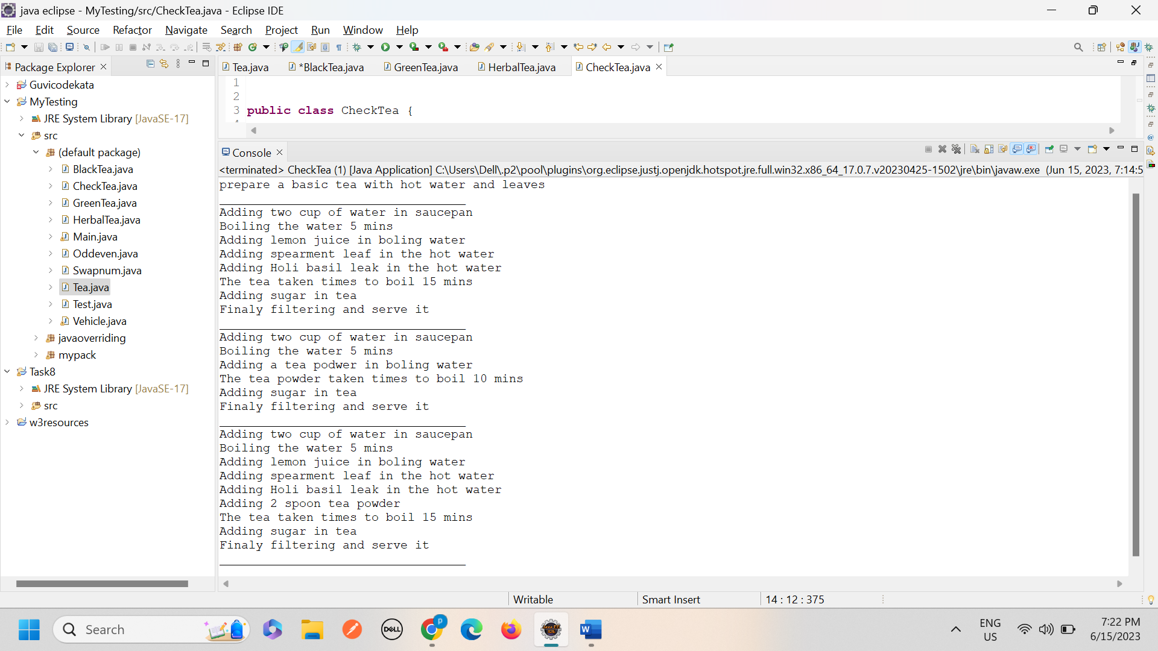

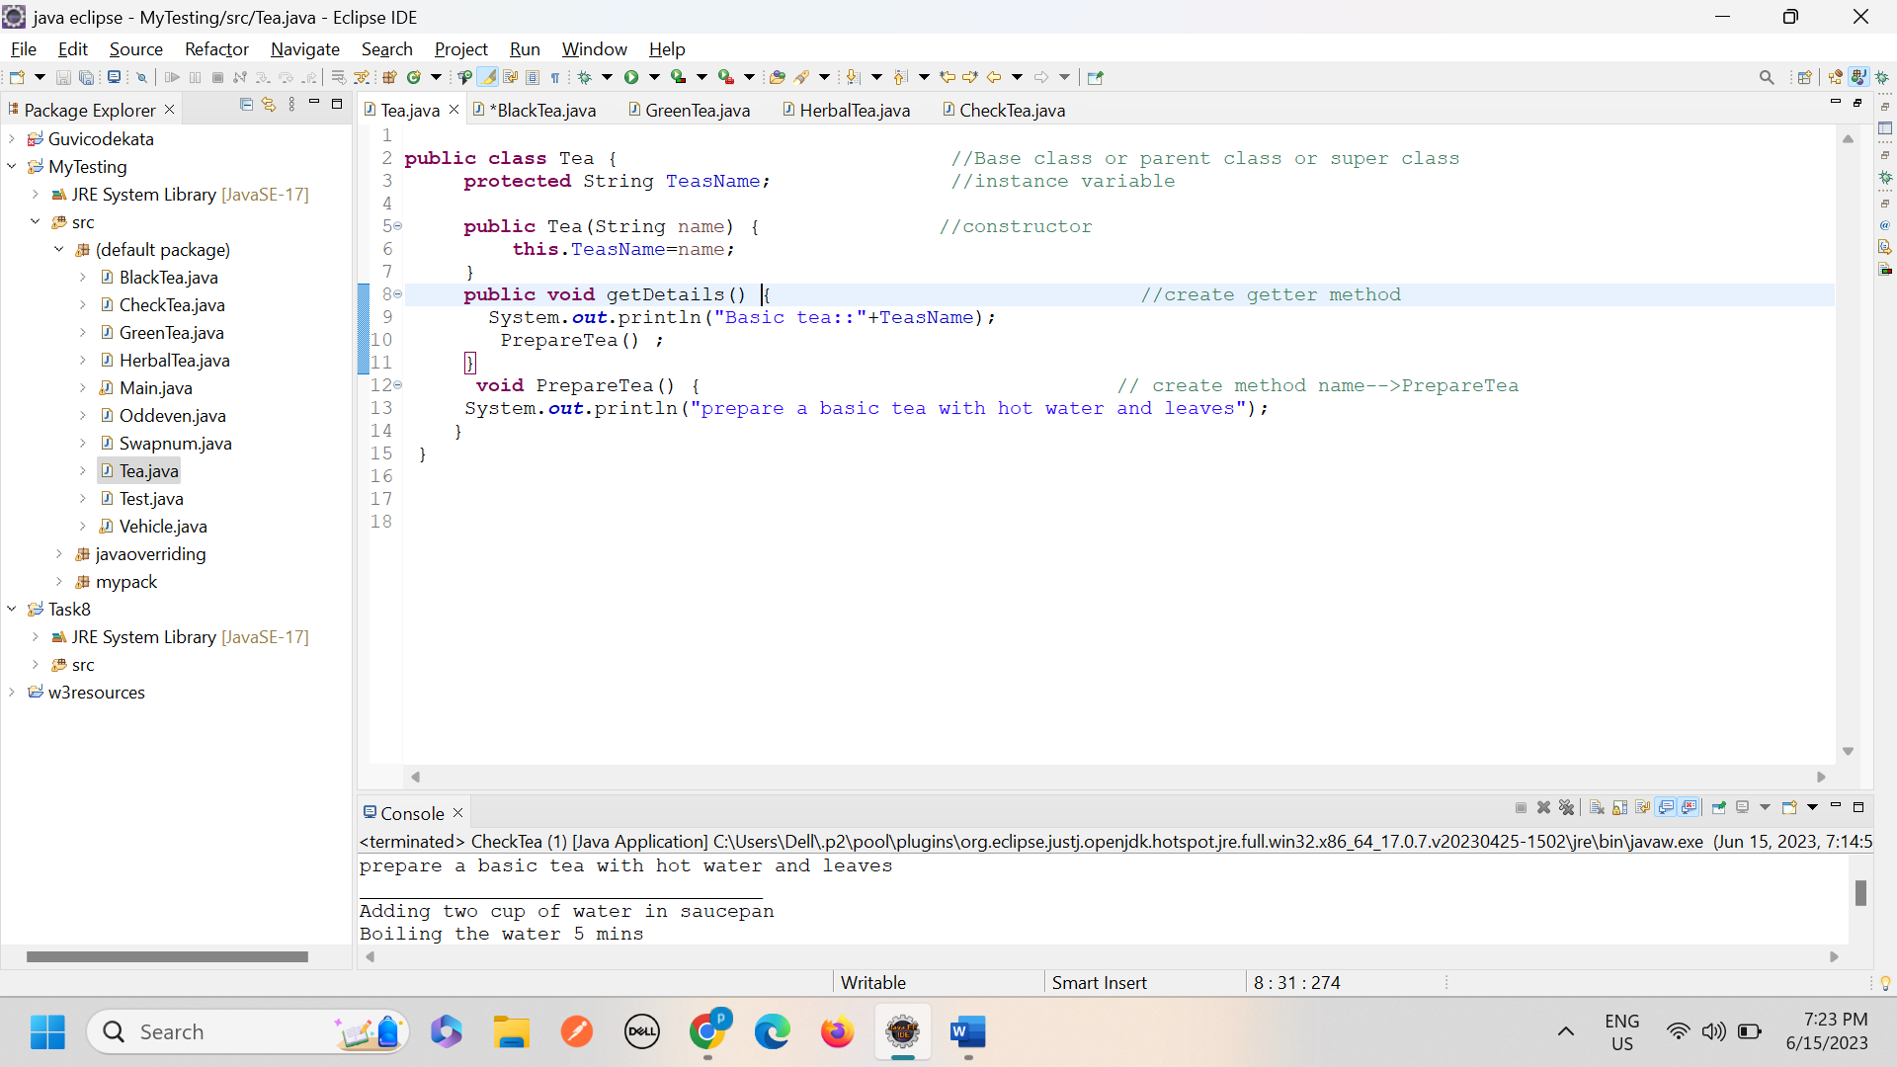

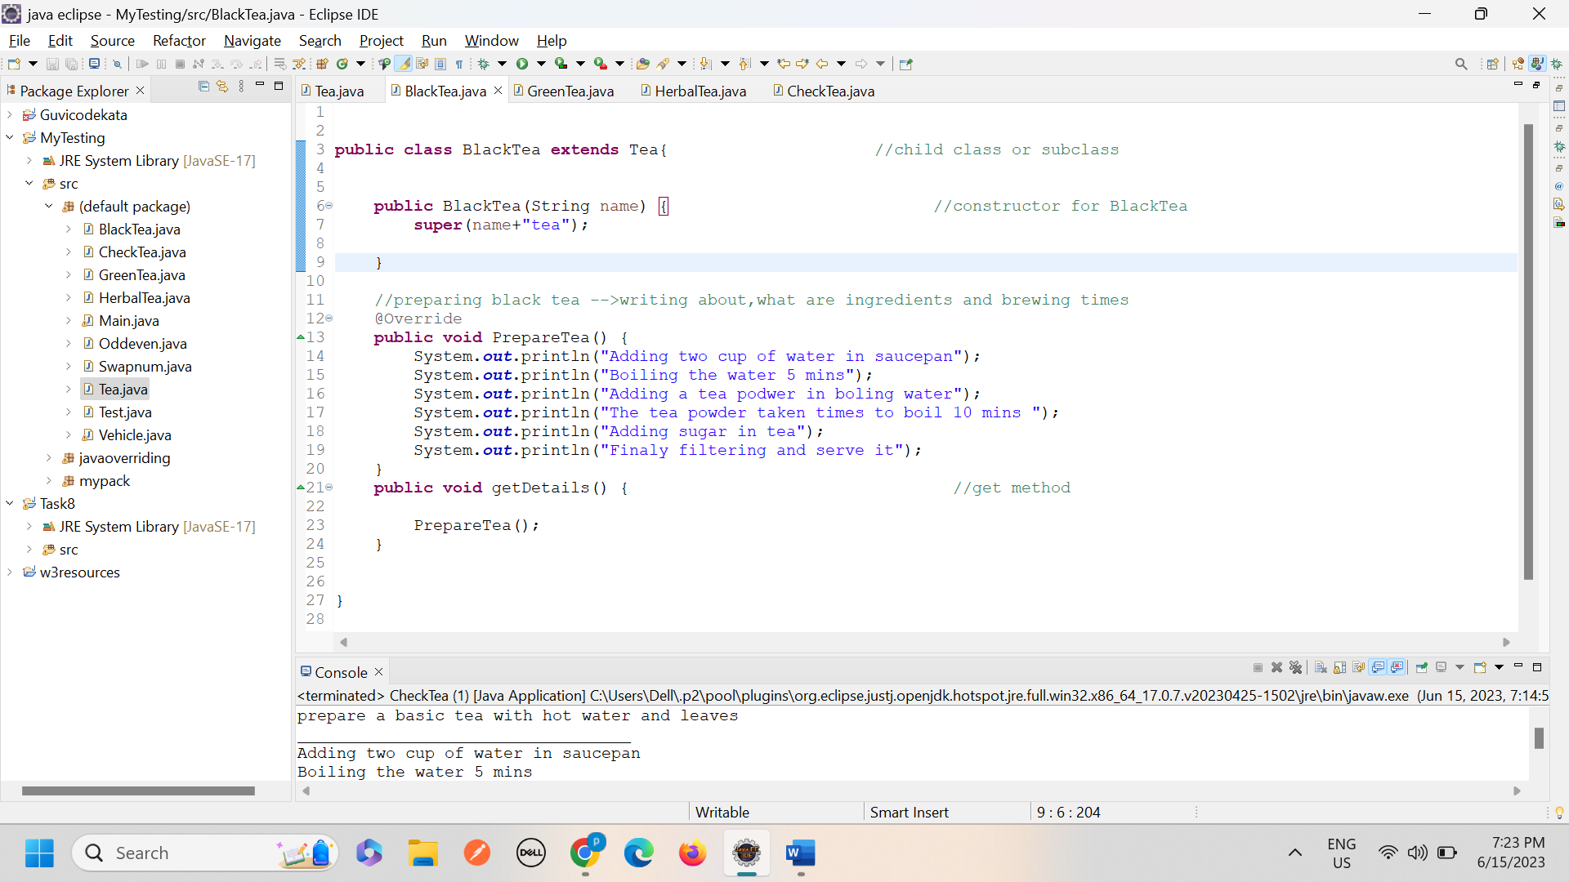

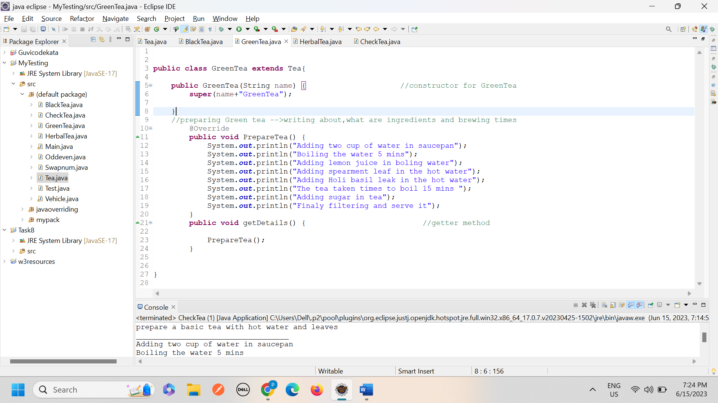

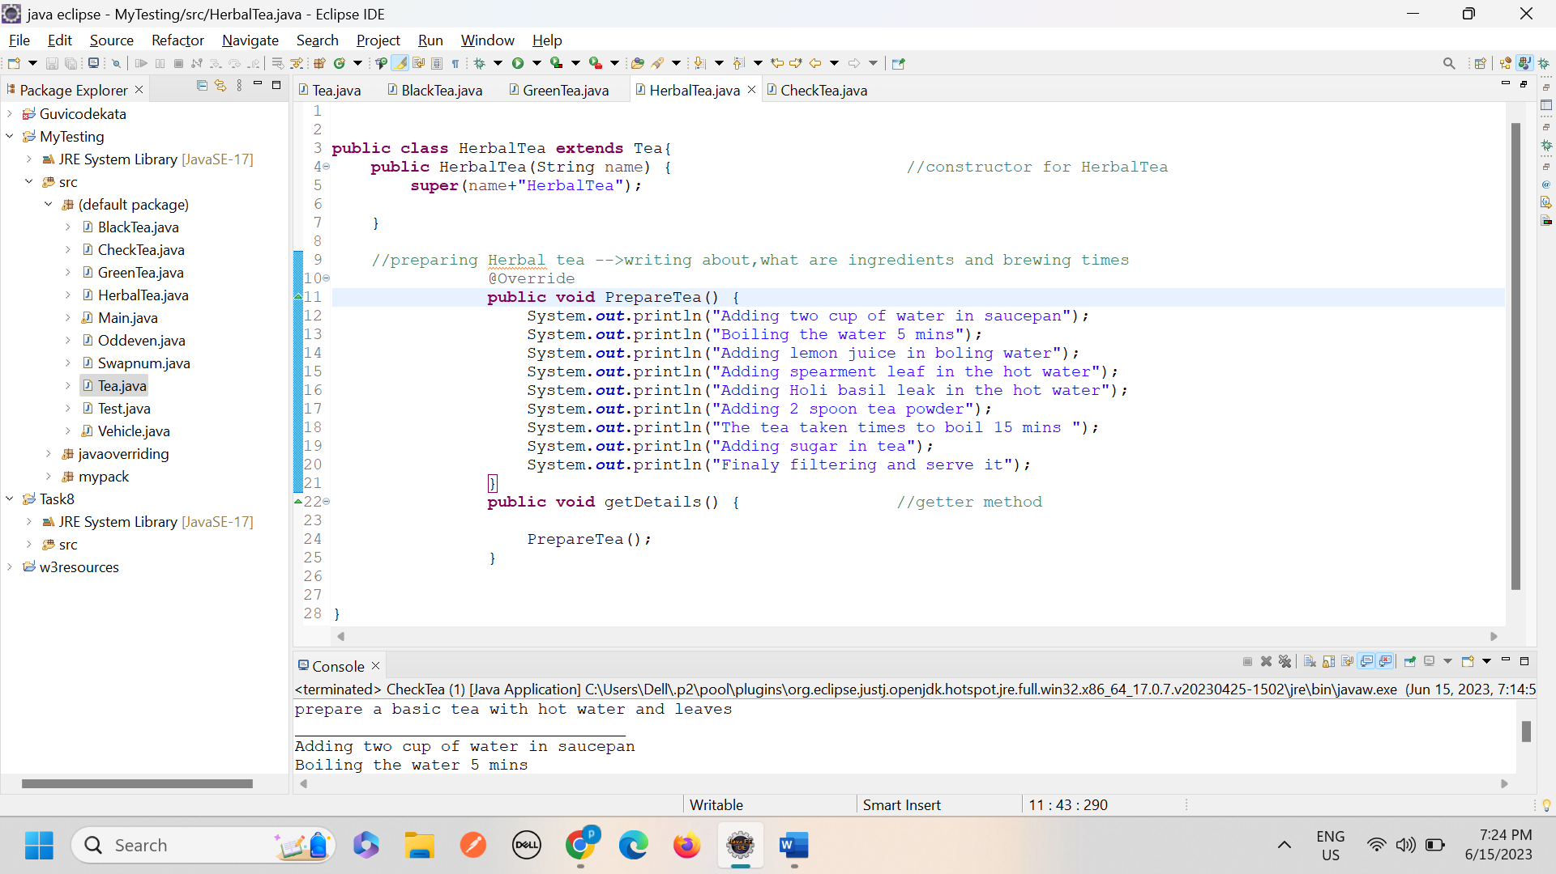

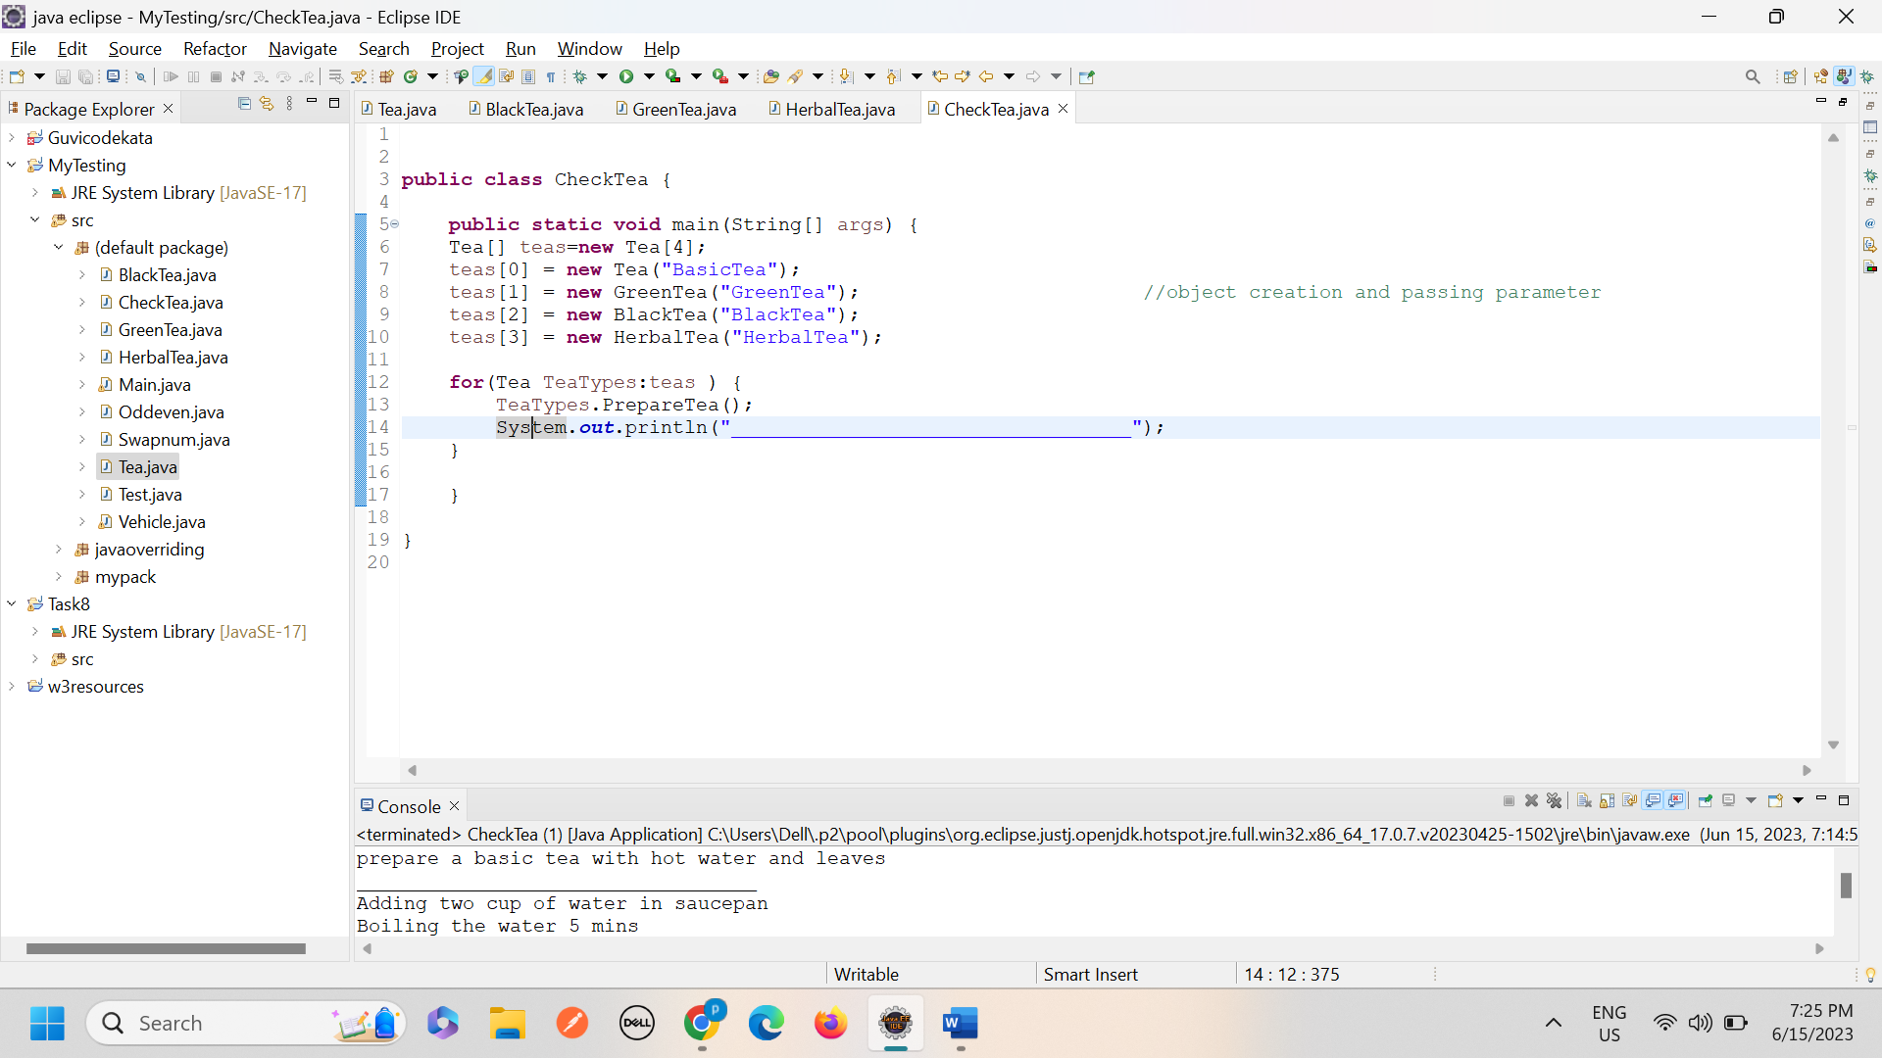

***---------------------------------------X------------------------------------------------X-----------------------------------------------X---------------***